**Retail Data Analysis Report**

***-Detailed Findings and Actionable Insights***

* **QUICK BRIEF**

In today’s competitive retail landscape, data-driven insights are critical for driving revenue growth, optimizing inventory, and fine-tuning marketing strategies. This analysis dives deep into retail transaction data spanning two periods: 2009-2010 and 2010-2011. The objectives are to:

* Understand overall sales trends and seasonal patterns.
* Analyze customer behavior to identify high-value segments.
* Assess product performance to determine bestsellers versus underperformers.
* Evaluate geographic sales distributions for market expansion opportunities.
* Utilize clustering techniques to segment customers, enabling targeted marketing and retention strategies.

This comprehensive study not only provides detailed exploratory insights but also leverages clustering algorithms to yield actionable intelligence that can guide business strategies across multiple domains.

**Data Processing, Wrangling, and Data Structure**

1. **Data Acquisition and Initial Loading**

The dataset under investigation was collected from retail transactions spanning two periods (2009-2010 and 2010-2011). The raw data was stored in an Excel file with separate sheets for each time and period. The initial step involved reading these sheets into a unified DataFrame.

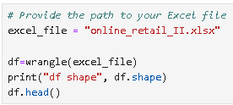

**Key steps in data acquisition:**

* **Loading Multiple Sheets:**  
  Using Python’s pandas library, both sheets (named "Year 2009-2010" and "Year 2010-2011") were loaded. Each sheet was assigned a new column (Period) to denote the time frame, facilitating later comparative analyses.
* **Combining Datasets:**  
  The individual DataFrames were concatenated into a single, unified DataFrame, ensuring that analysis across periods would be consistent and comprehensive.

1. **Data Cleaning and Preprocessing**

Before any meaningful analysis could be performed, data cleaning was essential to remove inconsistencies and errors:

* **Handling Missing Values:**  
  Missing descriptions were replaced with a placeholder ("No description") to ensure no product was left unidentified. Transactions missing a customer ID were dropped, since customer behavior analysis required a complete record.
* **Removing Duplicates and Negative Values:**  
  The dataset was checked for duplicates, and no duplicate rows were found after rigorous testing. Negative revenue transactions (possibly returns or errors) were filtered out to maintain focus on positive sales contributions.
* **Date Conversion:**  
  The InvoiceDate was converted into a datetime object to facilitate time-based analysis, and additional time features (year, month, quarter, and a combined YearMonth field) were created.

1. **Feature Engineering and Data Structuring**

To enrich the dataset for analysis, new columns were engineered:

* **Revenue Calculation:**  
  A new column, Revenue, was computed as the product of Quantity and Price. This provided a monetary metric that could be tracked over time and across segments.
* **Temporal Features:**  
  Additional features such as Year, Month, Quarter, and YearMonth were extracted from the InvoiceDate column. These features enable analysis at multiple granular levels (daily, monthly, quarterly, and yearly).
* **Final Data Structure:**  
  The cleaned and enriched DataFrame consists of **793,680** rows and **14** columns. Each row corresponds to a transaction, and the columns include identifiers (Invoice, StockCode, Customer ID), transaction details (Quantity, Price, InvoiceDate, Revenue), and derived time-related features. This robust structure serves as the foundation for subsequent exploratory analysis and clustering.

**Exploratory Data Analysis (EDA)**

The goal of the EDA is to unearth trends, patterns, and anomalies within the retail data. This section covers several dimensions of analysis from sales trends to customer behavior and product performance.

1. **Sales Trends Analysis**

**Monthly Sales Trends**

Monthly sales trends were examined by aggregating the total quantity sold for each year-month period:

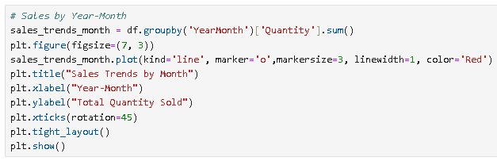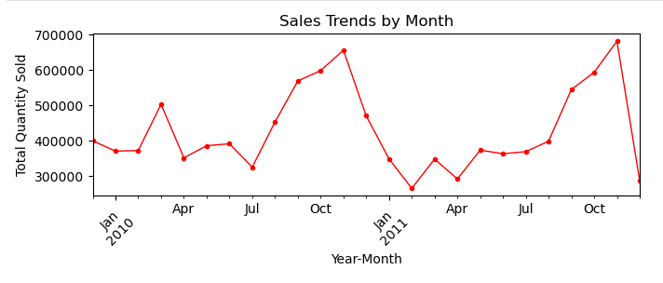

* **Visualization:**  
  A line chart plotting YearMonth against Quantity provided a clear view of fluctuations in monthly sales. Markers and line plots highlighted key months where sales surged or dropped.
* **Insights:**
  + **Peak Sales:** November consistently recorded the highest sales, likely driven by pre-holiday shopping.
  + **Post-Holiday Decline:** Sales showed a sharp decline in December after the holiday rush, suggesting that inventory management and marketing strategies might need recalibration during this period.
  + **Seasonal Volatility:** The analysis identified seasonal patterns, with dips in early-year months (e.g., February) and mid-year (July) that could be attributed to post-holiday slowdowns or other external factors.

**Quarterly Sales Trends**

Quarterly aggregation of sales provided insights at a broader temporal scale:

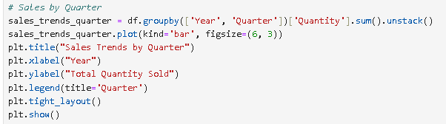

* **Visualization:**  
  A bar chart categorized by year and quarter clearly illustrates the performance differences between Q1, Q2, Q3, and Q4.
* **Key Findings:**
  + **Q4 Dominance:** Q4 remained the strongest quarter in terms of sales volume across both years. However, despite high sales in Q4, there was an observable drop in revenue in the subsequent period.
  + **Q1 Decline in 2011:** A significant decline in Q1 of 2011 (approximately 22.8%) indicated potential challenges during the early part of the year, warranting further investigation into market conditions or operational issues.

**Yearly Sales Overview**

Analyzing yearly sales totals provided an overall picture of the company’s performance over the two-year span:

* **Visualization:**  
  A bar chart comparing yearly total quantities revealed dramatic shifts, particularly the substantial increase from 2009 to 2010 and the subsequent decline in 2011.
* **Insights:**
  + **Sales Surge in 2010:** There was a massive surge in sales (over 1263% increase) from 2009 to 2010, suggesting successful marketing or inventory strategies in that year.
  + **2011 Downturn:** The decline of 10.7% in 2011, despite strong seasonal performance, pointed to potential challenges in sustaining growth. This led to the identification of underperformance in key months (especially Q1 and Q4).

1. **Customer Segmentation and Behavioral Insights**

Customer segmentation is crucial for tailoring marketing efforts and improving customer retention:

* **Methodology:**  
  Aggregation was performed on a per-customer basis. Each customer’s total revenue and the number of unique transactions (Invoice counts) were computed. A flag was then set to identify repeat buyers and to highlight high-value customers (top 25% based on revenue).
* **Visualization:**  
  A scatter plot mapping TransactionCount against Revenue (with high-value customers highlighted) revealed clear clusters of customer behavior.

* **Insights:**
  + **High-Value vs. Low-Value Customers:** Although 80% of the customers were repeat buyers, a small fraction (the top 25%) accounted for the majority of revenue.
  + **Opportunities for Upselling:** Mid-tier customers showed potential for growth if incentivized properly. Moreover, the disparity between one-time buyers and repeat high-spenders underlined the importance of targeted retention programs.

1. **Product Performance Analysis**

Evaluating product performance helped to pinpoint bestsellers and items that underperformed:

* **Aggregation:**  
  Total quantities sold were calculated for each product (identified by StockCode).
* **Visualization:**  
  Bar charts were used to display the top 5 best-selling products and the 5 products with the lowest sales figures.

* **Key Findings:**
  + **Dominance of Bestsellers:** A few products (e.g., StockCode 84077) dominated the sales numbers, with quantities reaching over 100,000 units.
  + **Inventory Imbalance:** Conversely, some products recorded only one unit sold, indicating either low market demand or issues in product placement/marketing.
  + **Actionable Insights:**
    - **Inventory Optimization:** Focus on optimizing inventory levels for bestsellers.
    - **Review of Underperformers:** Low-selling products need a review regarding quality, pricing, or marketing to either reposition or phase out these items.

1. **Geographic Sales Insights**

Understanding geographic performance is critical for expanding market reach:

* **Sales Aggregation by Country:**  
  The dataset was aggregated by country using sales volume (quantity sold) as a proxy for market performance.
* **Visualization:**  
  A bar chart showcased the top 10 countries by sales volume, highlighting the dominant markets.

* **Insights:**
  + **United Kingdom Dominance:** The UK accounted for approximately 89% of the total sales volume, reinforcing its position as the core market.
  + **European Expansion:** Other European markets (such as the Netherlands, France, and Germany) showed moderate sales figures, representing opportunities for growth.
  + **Underperforming Regions:** Regions with minimal sales (such as select Middle Eastern or Asian countries) may require strategic interventions or even reconsideration of market presence.

**Clustering Analysis: Findings and Insights**

Clustering techniques were used to segment customers based on purchasing behavior. Three different clustering methods were applied: K-Means, DBSCAN, and Hierarchical Clustering. Each method provided unique perspectives on customer segmentation.

1. **K-Means Clustering**

K-Means clustering was applied to a feature set comprising total revenue, transaction count, and average revenue per transaction:

* **Process:**
  + The features were standardized using a scaler to ensure that each metric contributed equally.
  + An optimal number of clusters (in this case, three) was chosen based on methods such as the elbow method and silhouette scores.
  + The algorithm then assigned customers to one of the clusters based on their purchasing behavior.

* **Findings:**
  + **Cluster 0 (Low-Value Customers):**  
    These customers had lower overall revenue and a moderate number of transactions.  
    *Actionable Insight:* Introduce targeted promotions (e.g., “We miss you” discounts) to increase engagement.

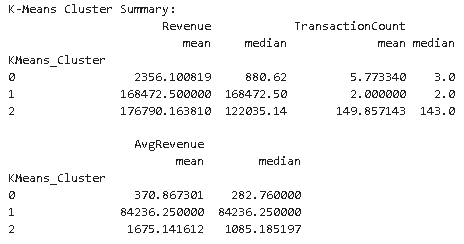

* + **Cluster 1 (Occasional High-Spenders):**  
    Customers in this group had very high revenue figures despite few transactions.  
    *Actionable Insight:* Offer premium memberships or loyalty rewards to encourage more frequent purchasing.
  + **Cluster 2 (Frequent High-Value Buyers):**  
    Representing high revenue and frequent transactions, this cluster identified the core customer base.  
    *Actionable Insight:* Strengthen retention through exclusive offers and personalized communication.

1. **DBSCAN Clustering**

DBSCAN (Density-Based Spatial Clustering of Applications with Noise) was employed to capture clusters of varying shapes and identify outliers:

* **Process:**
  + The same standardized feature set was used.
  + DBSCAN parameters were tuned (eps and min_samples) to define clusters based on density.
  + Unlike K-Means, DBSCAN can detect noise and outliers, which was beneficial in understanding atypical customer behavior.

* **Findings:**
  + **Cluster -1 (High-Value Outliers):**  
    Customers in this cluster, despite having fewer transactions, contributed significantly to overall revenue.  
    *Actionable Insight:* Reward these loyal customers with special offers and volume discounts.
  + **Cluster 0 (Low-Engagement Majority):**  
    A significant portion of customers with low transaction counts and modest revenue.  
    *Actionable Insight:* Reactivate these customers with targeted email campaigns and promotions.

* + **Cluster 1 (Big-Ticket Infrequent Buyers):**  
    These customers had a few high-value transactions.  
    *Actionable Insight:* Incentivize repeat purchases by offering VIP perks and limited-time offers.

1. **Hierarchical Clustering**

Hierarchical clustering was used to build a dendrogram and understand the nested relationships among customers:

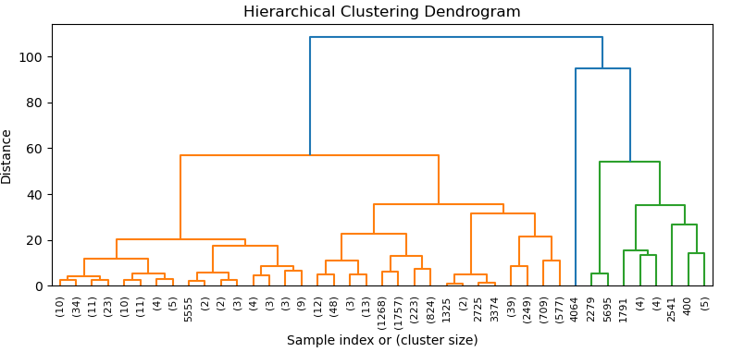

* **Process:**
  + A linkage matrix was computed using Ward’s method.
  + A dendrogram was plotted to visualize the nested clusters.
  + The dendrogram was “cut” at a predetermined level to form three distinct clusters, consistent with previous clustering approaches.

* **Findings:**
  + **Cluster 1 (Low-Value Customers):**  
    Similar to previous results, this cluster had low revenue and fewer transactions.  
    *Actionable Insight:* Engage these customers with personalized discounts and product recommendations.
  + **Cluster 2 (High-Value, Frequent Buyers):**  
    Customers in this cluster generated high revenue with a large number of transactions.  
    *Actionable Insight:* Focus on loyalty programs and exclusive promotions to retain these customers.

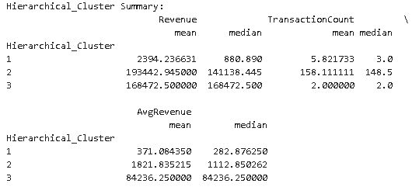

* + **Cluster 3 (Occasional High-Spenders):**  
    These customers, although having high revenue per transaction, exhibited low transaction frequency.  
    *Actionable Insight:* Encourage more frequent purchases through premium services and tailored marketing efforts.

Across all three clustering techniques, the segmentation insights were largely consistent, providing confidence in the reliability of the results. The clustering analysis not only validated the presence of distinct customer segments but also pinpointed specific opportunities to optimize marketing and customer retention strategies.

**Summary**

The comprehensive analysis of retail transaction data yielded the following key insights:

* **Sales Trends:**
  + A dramatic surge in sales was observed from 2009 to 2010, followed by a decline in 2011.
  + Seasonal patterns showed peak sales in November with a subsequent decline in December, and notable underperformance in Q1 of 2011.
* **Customer Segmentation:**
  + A small group of high-value customers contributes disproportionately to total revenue.
  + The majority of customers are repeat buyers but fall into the low- or mid-tier segments.
* **Product Performance:**
  + A handful of products dominate sales, while some items show negligible sales, highlighting potential issues in product selection or marketing.
* **Geographic Insights:**
  + The UK is the primary market, with mid-tier opportunities in other European countries.
* **Clustering Analysis:**
  + Multiple clustering methods identified similar segments, reinforcing the existence of distinct groups such as low-value, occasional high-spenders, and frequent high-value buyers.

The integration of time-series analyses, customer segmentation, and clustering has provided a robust framework for understanding the underlying dynamics of retail performance.

**Recommendations**

Based on the analysis, several actionable recommendations have been identified:

1. **Enhance Early-Year Performance:**
   * **Targeted Promotions:** Develop and launch marketing campaigns in Q1 to mitigate the early-year slump, possibly through special discounts or limited-time offers.
   * **Inventory Optimization:** Adjust stock levels and reorder strategies in anticipation of the seasonal dip, ensuring that excess inventory is minimized and cash flow is preserved.
2. **Retain High-Value Customers:**
   * **Loyalty Programs:** Implement a loyalty rewards program tailored to high-value customers. Offer exclusive discounts, early access to new products, and VIP customer service.
   * **Personalized Communication:** Use data insights to send personalized recommendations and incentives to encourage repeat business, particularly among occasional high-spenders.
3. **Expand into Growth Markets:**
   * **Mid-Tier Market Focus:** Invest in market research and localized marketing strategies for mid-tier European markets (e.g., Netherlands, France, Germany) to capture additional market share.
   * **New Market Strategies:** For underperforming regions, conduct a detailed audit to identify and remove barriers to entry, such as pricing strategy adjustments or logistical improvements.
4. **Product Portfolio Optimization:**
   * **Inventory Review:** For products that have consistently underperformed (e.g., items that sold only a few units), consider discontinuing or bundling them with bestsellers.
   * **Marketing Adjustments:** Enhance promotional efforts around best-selling products to leverage their strong market performance, while investigating quality or demand issues for low-selling items.
5. **Leverage Advanced Analytics:**
   * **Ongoing Data Monitoring:** Set up dashboards to continuously monitor key performance indicators (KPIs) such as monthly sales trends, customer segmentation metrics, and inventory levels.
   * **Predictive Modeling:** Explore advanced predictive analytics to forecast demand, thereby aligning marketing efforts and inventory management with anticipated customer behavior.
6. **Refine Customer Engagement Strategies:**
   * **Segment-Specific Offers:** Use the insights from clustering to craft targeted messaging and promotions for each customer segment. For instance, reactivation campaigns for low-engagement customers and premium offers for occasional high-spenders.
   * **Feedback Mechanisms:** Implement mechanisms (e.g., surveys, feedback loops) to continuously gather customer insights and adjust strategies accordingly.

**Conclusion**

This detailed study of retail transaction data illustrates the power of data-driven decision making in the retail sector. The multifaceted analysis—from data wrangling and EDA to clustering and segmentation—reveals not only the patterns behind seasonal sales and product performance but also uncovers the behavioral characteristics of customers.

Key takeaways include:

* **Sales Volatility:** Despite a massive surge in sales from 2009 to 2010, the downturn in 2011 highlights the challenges of sustaining momentum in a competitive market. Addressing seasonal dips and enhancing early-year performance should be priorities.
* **Customer-Centric Strategies:** The clustering analysis underscored the importance of identifying and nurturing high-value customer segments. Tailoring retention strategies and incentivizing repeat purchases can significantly impact revenue.
* **Strategic Market Expansion:** While the United Kingdom remains the dominant market, there exists untapped potential in mid-tier European regions. A strategic focus on these markets can lead to diversified revenue streams.
* **Inventory and Product Management:** Streamlining the product portfolio by focusing on bestsellers and reviewing underperformers will enhance operational efficiency and support targeted marketing initiatives.

Ultimately, the insights and recommendations provided in this analysis offer a clear roadmap for refining sales strategies, optimizing inventory management, and enhancing customer engagement. As the retail environment continues to evolve, leveraging such detailed data analytics will be instrumental in achieving sustainable growth and competitive advantage.